Willis Allstead

4/23/18

CS 491

Lab 5

**Social Network**

1. Most central node by (by ID)
   1. Degree: 140
   2. Eigenvector: 157
   3. pageRank: 157
   4. Closeness: 154
   5. Betweenness: 66
2. Energy layout of the network, using the degree as node size
   1. Eigenvector centrality:

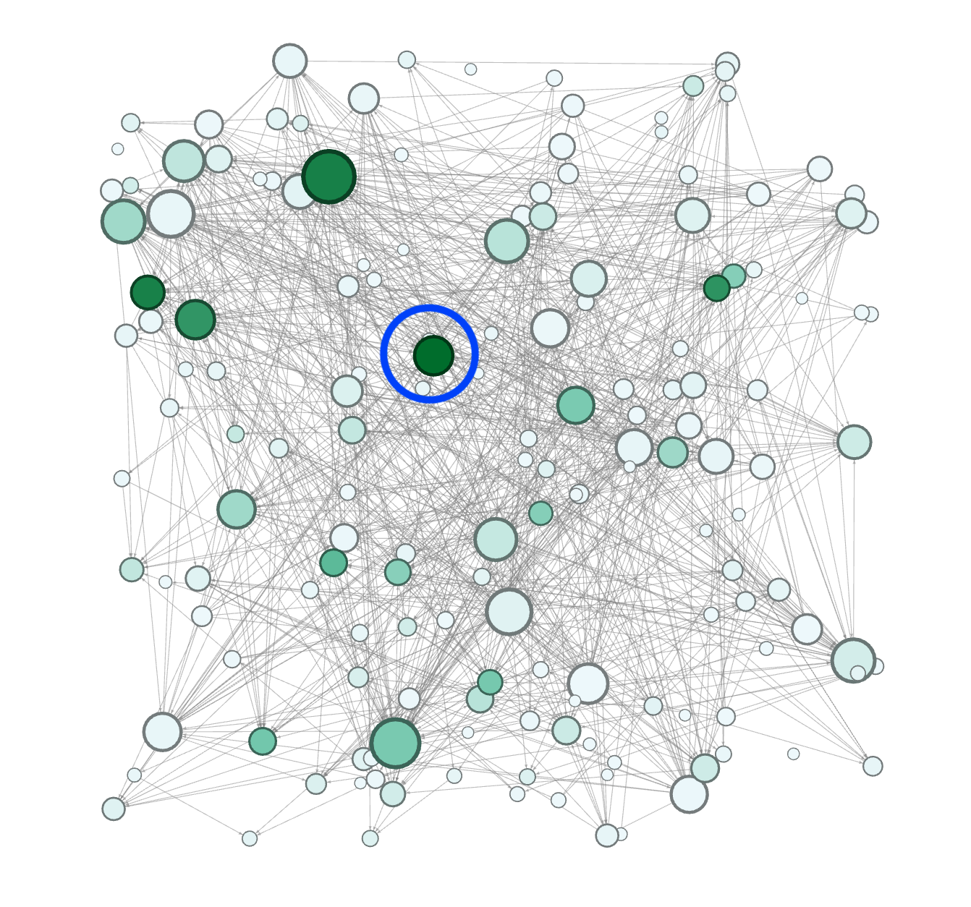

* 1. pageRank centrality:

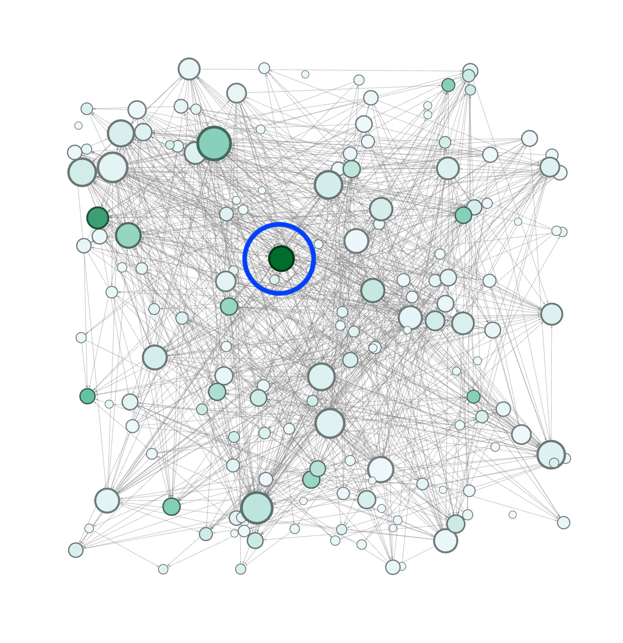

* 1. Closeness centrality:

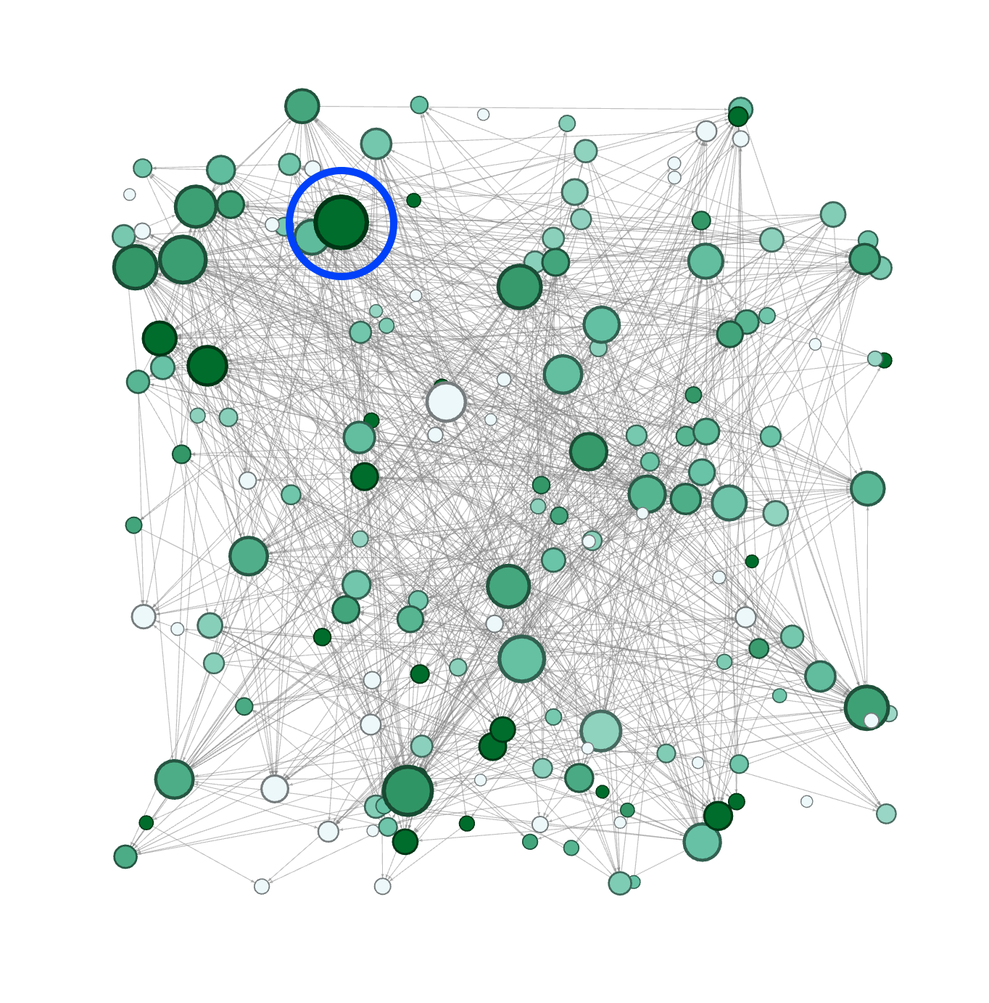

* 1. Betweenness centrality:

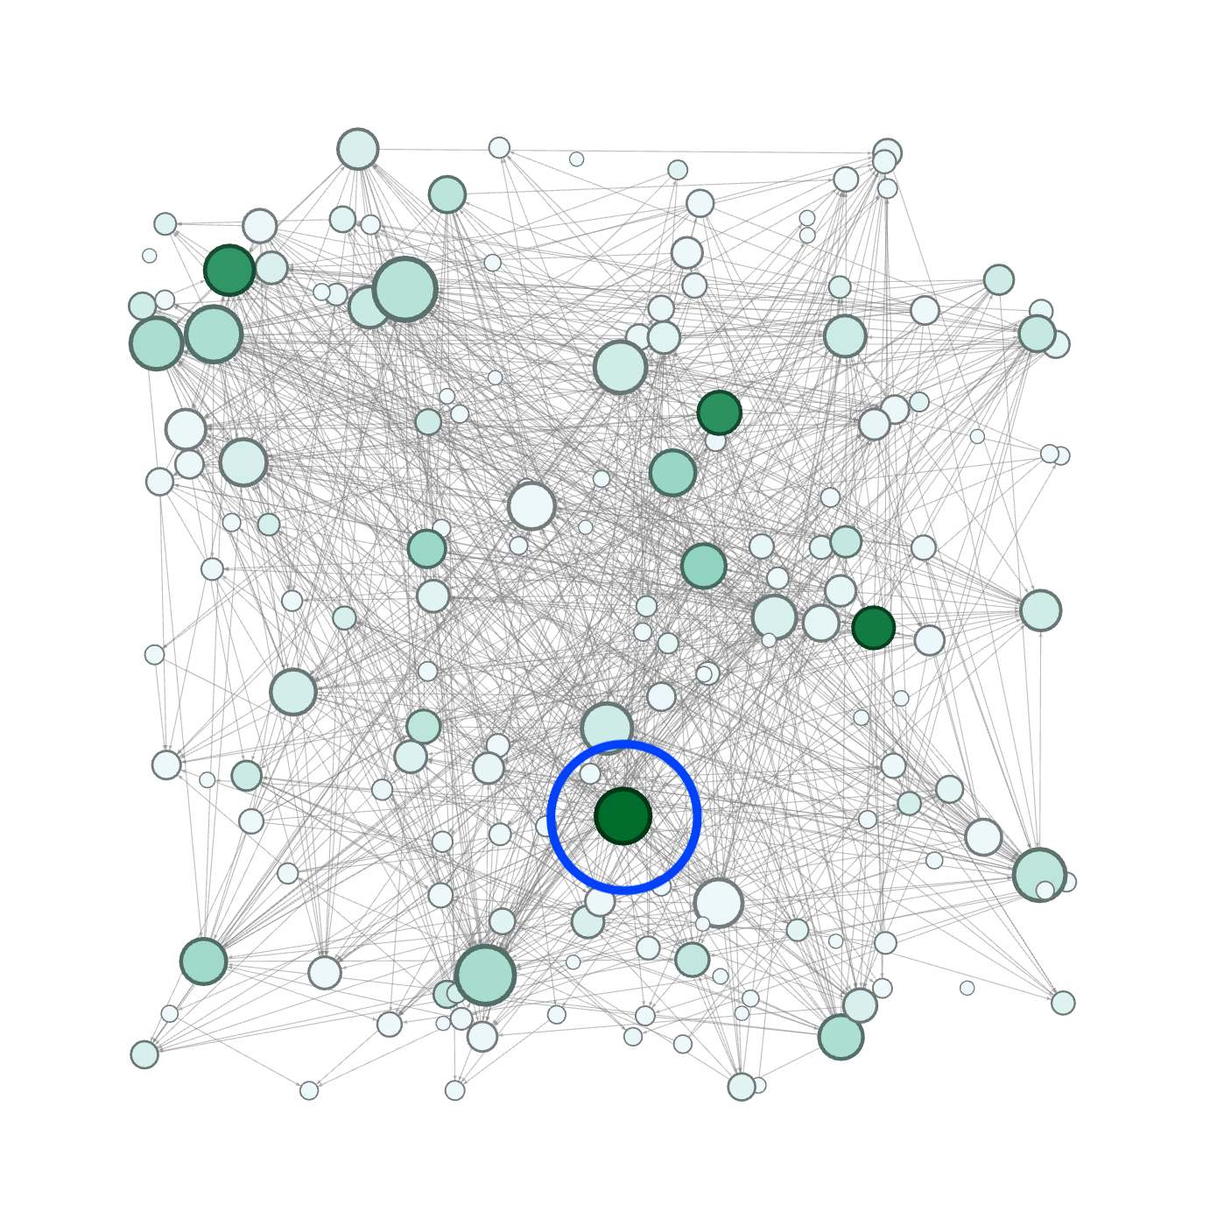

1. 4 vertices whose degree centrality rank differs the most from the other centralities (eigenvector, pageRank, closeness, and betweenness)
   1. Node with Id 13 has a high degree centrality, but low eigenvector, pageRank, betweenness, and closeness.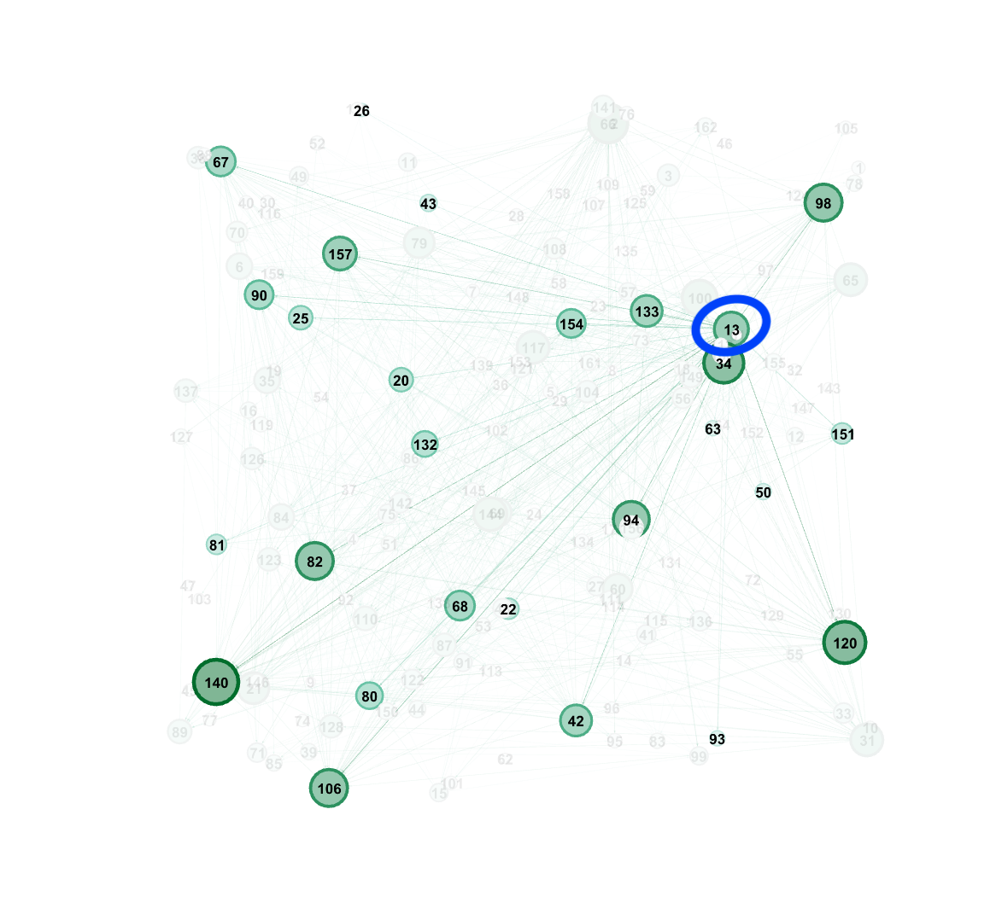
   2. Node with Id 6 has a medium degree centrality, but low eigenvector pageRank, betweenness, and closeness.

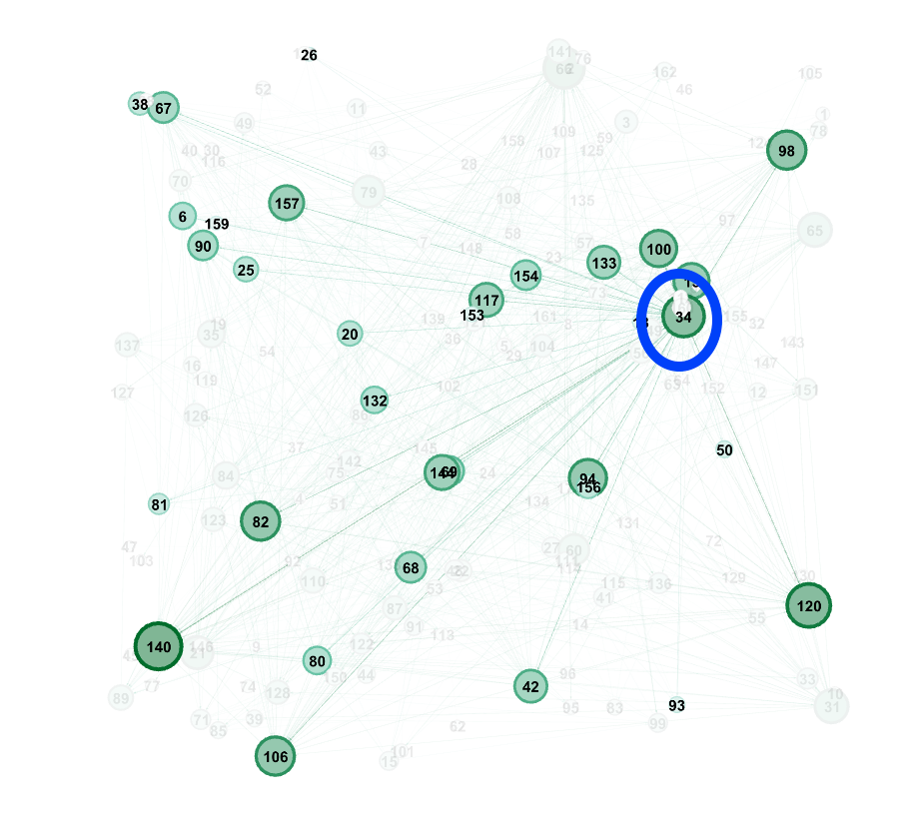

* 1. Node with Id 34 has a high degree centrality, but low eigenvector and pageRank, and fairly low betweenness, and closeness.

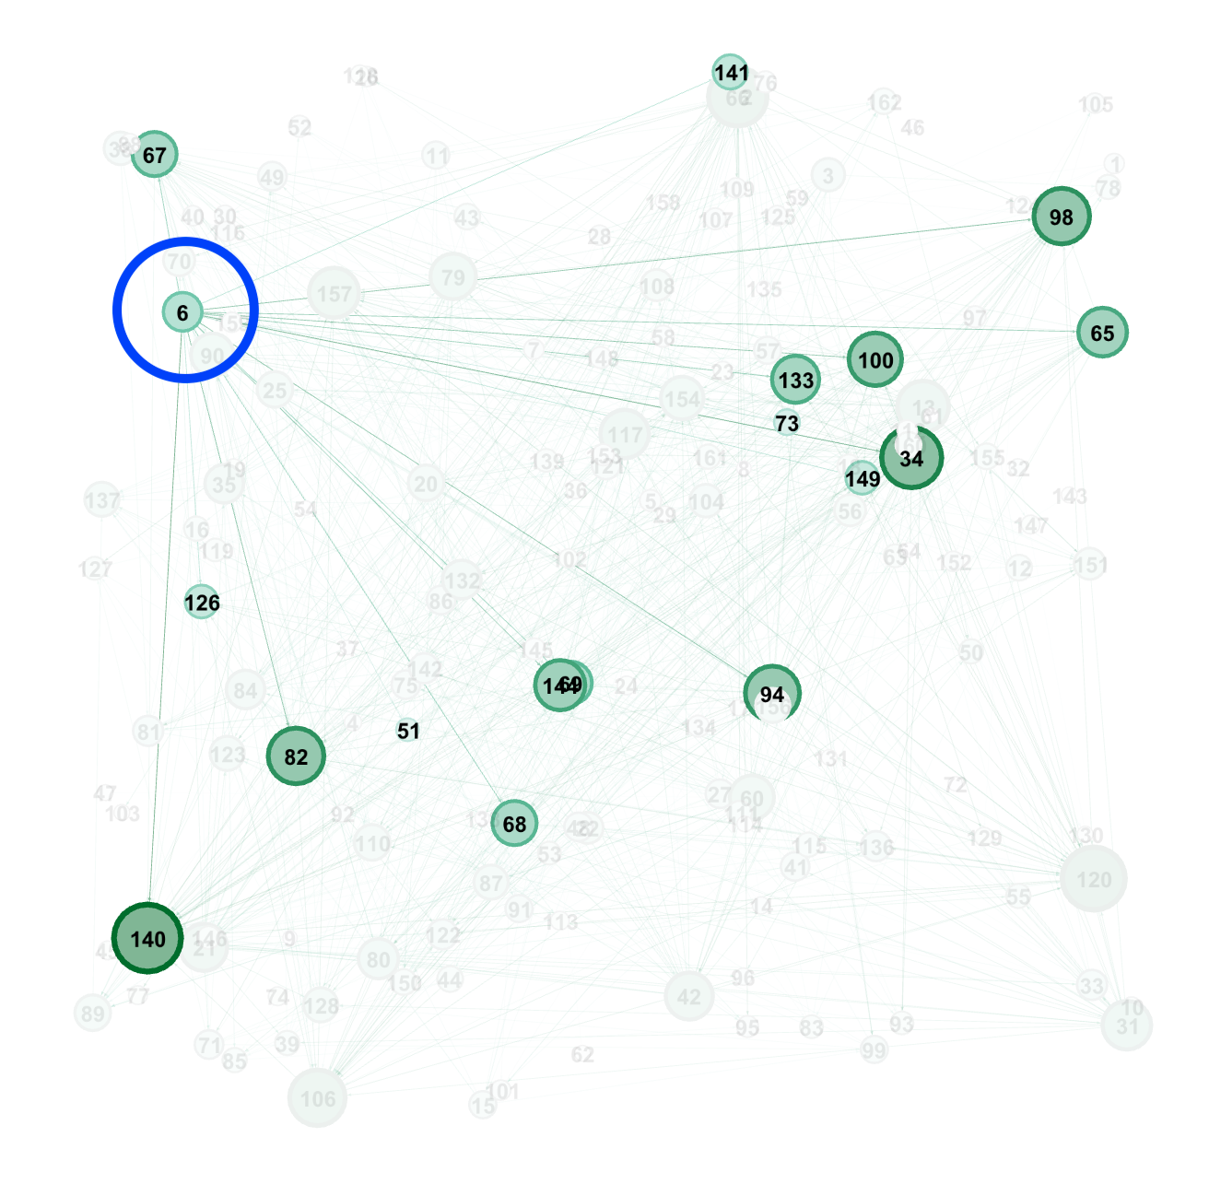

* 1. Node with Id 43 has a low degree centrality, but a relatively high eigenvector and pageRank, betweenness, and closeness.

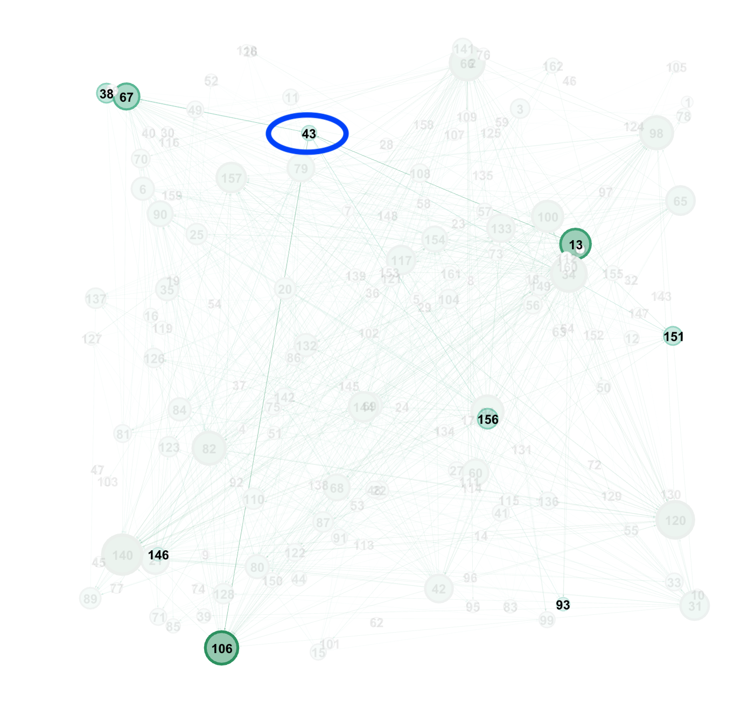

These differences are due to the different ways centralities are measured. Just because a node has a high degree centrality does not necessarily mean it has a high betweenness or other type of centrality. For example, if a node connects different two parts of the graph but has no other connections, it could have a high betweenness but not a high degree centrality.

1. I will be removing node 60 from the network:

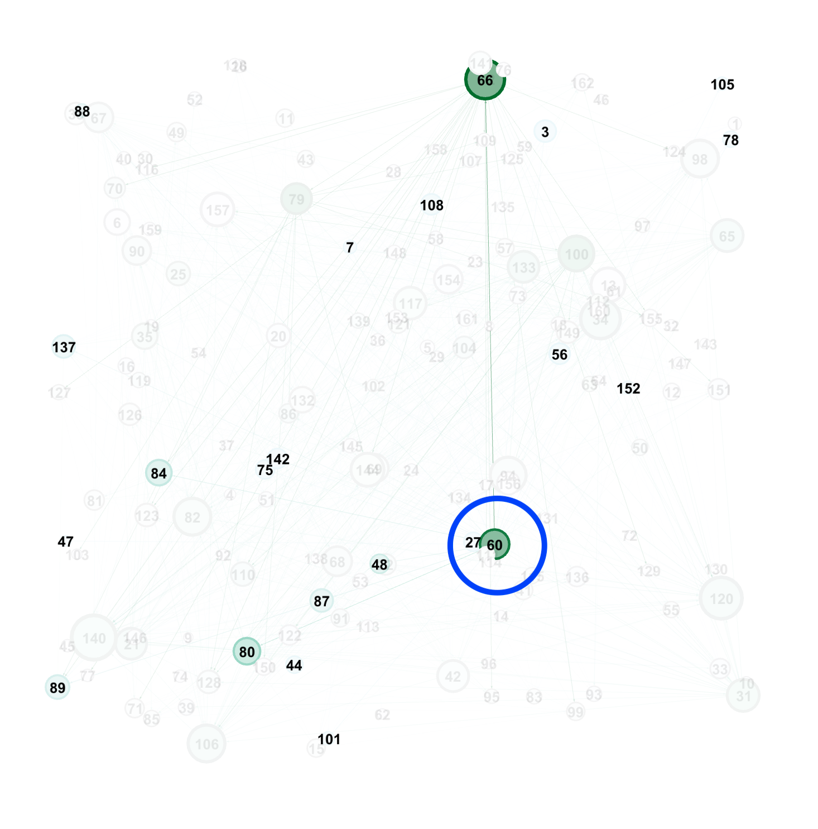

1. Node 79’s betweenness rank drastically dropped:

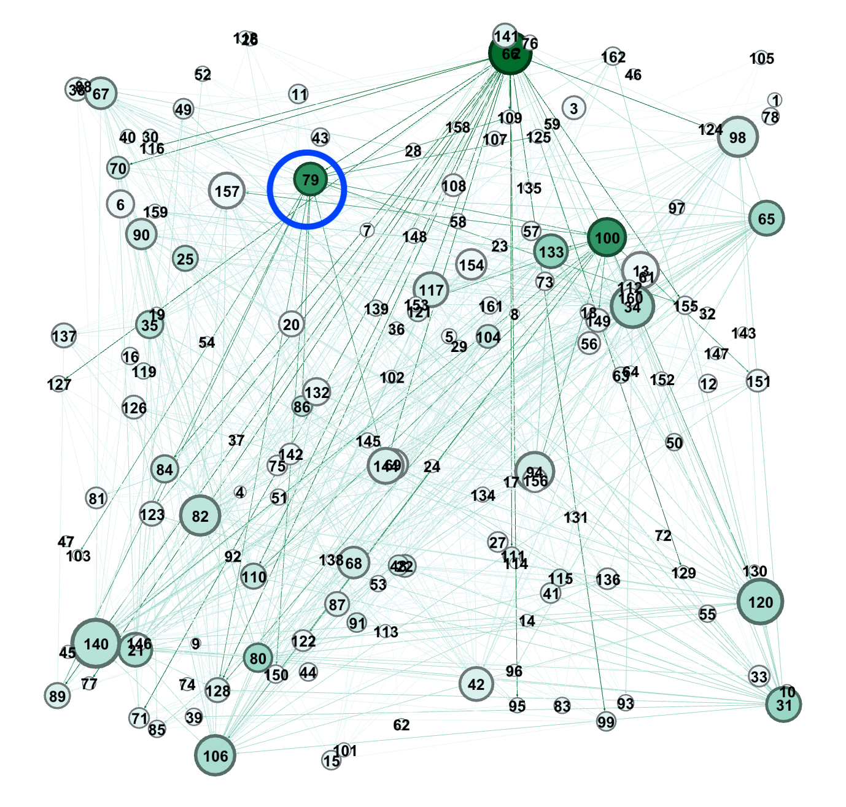

1. Node 127’s closeness rank increased the most:

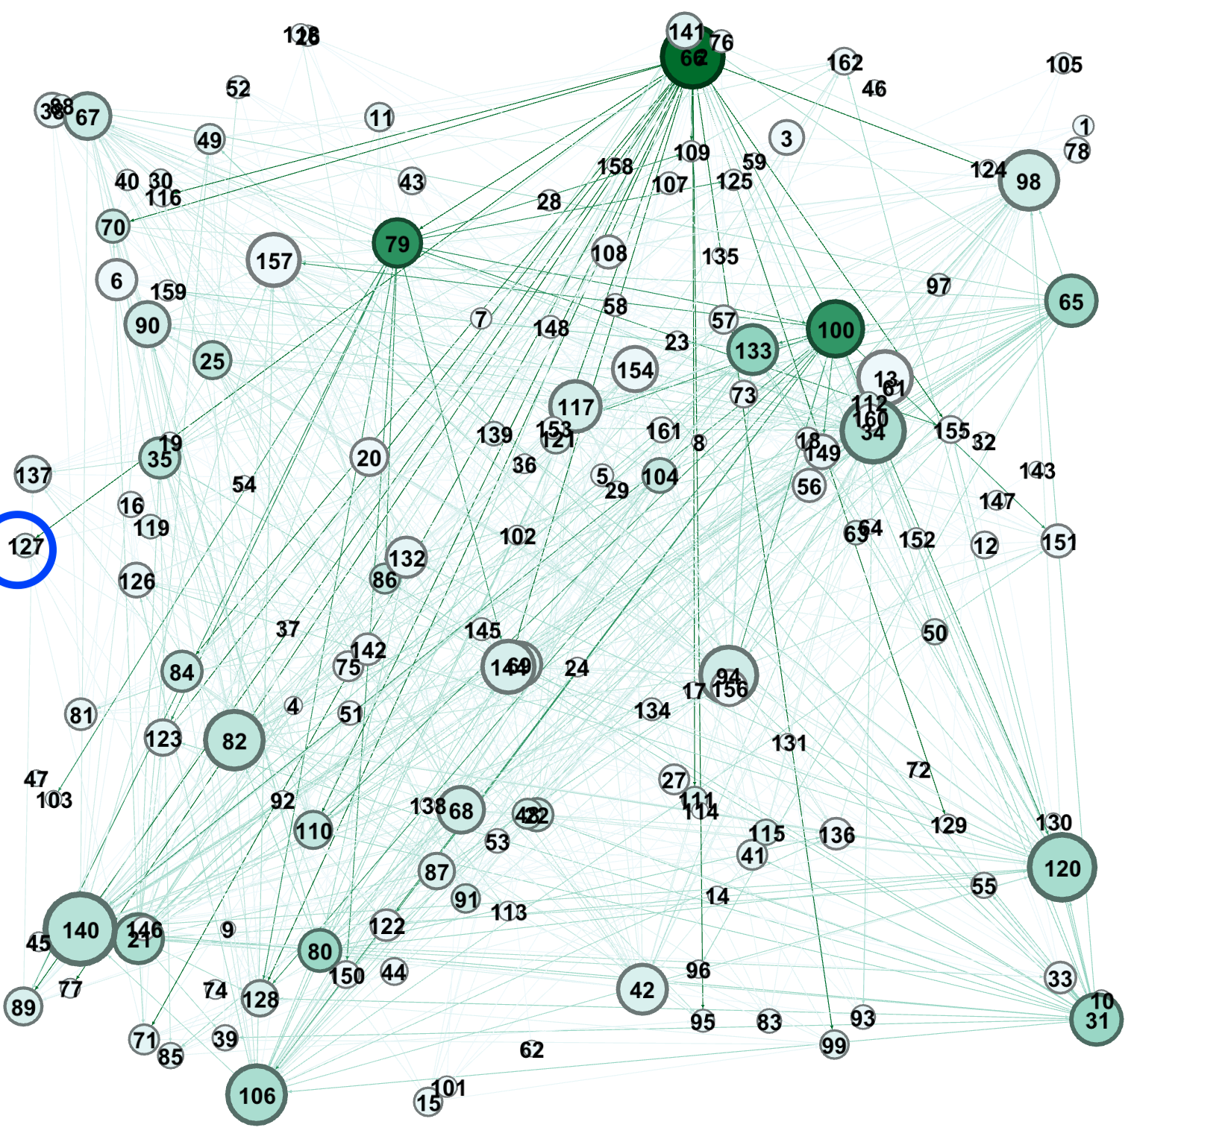

1. Node 157’s eigenvector rank decreased the most:

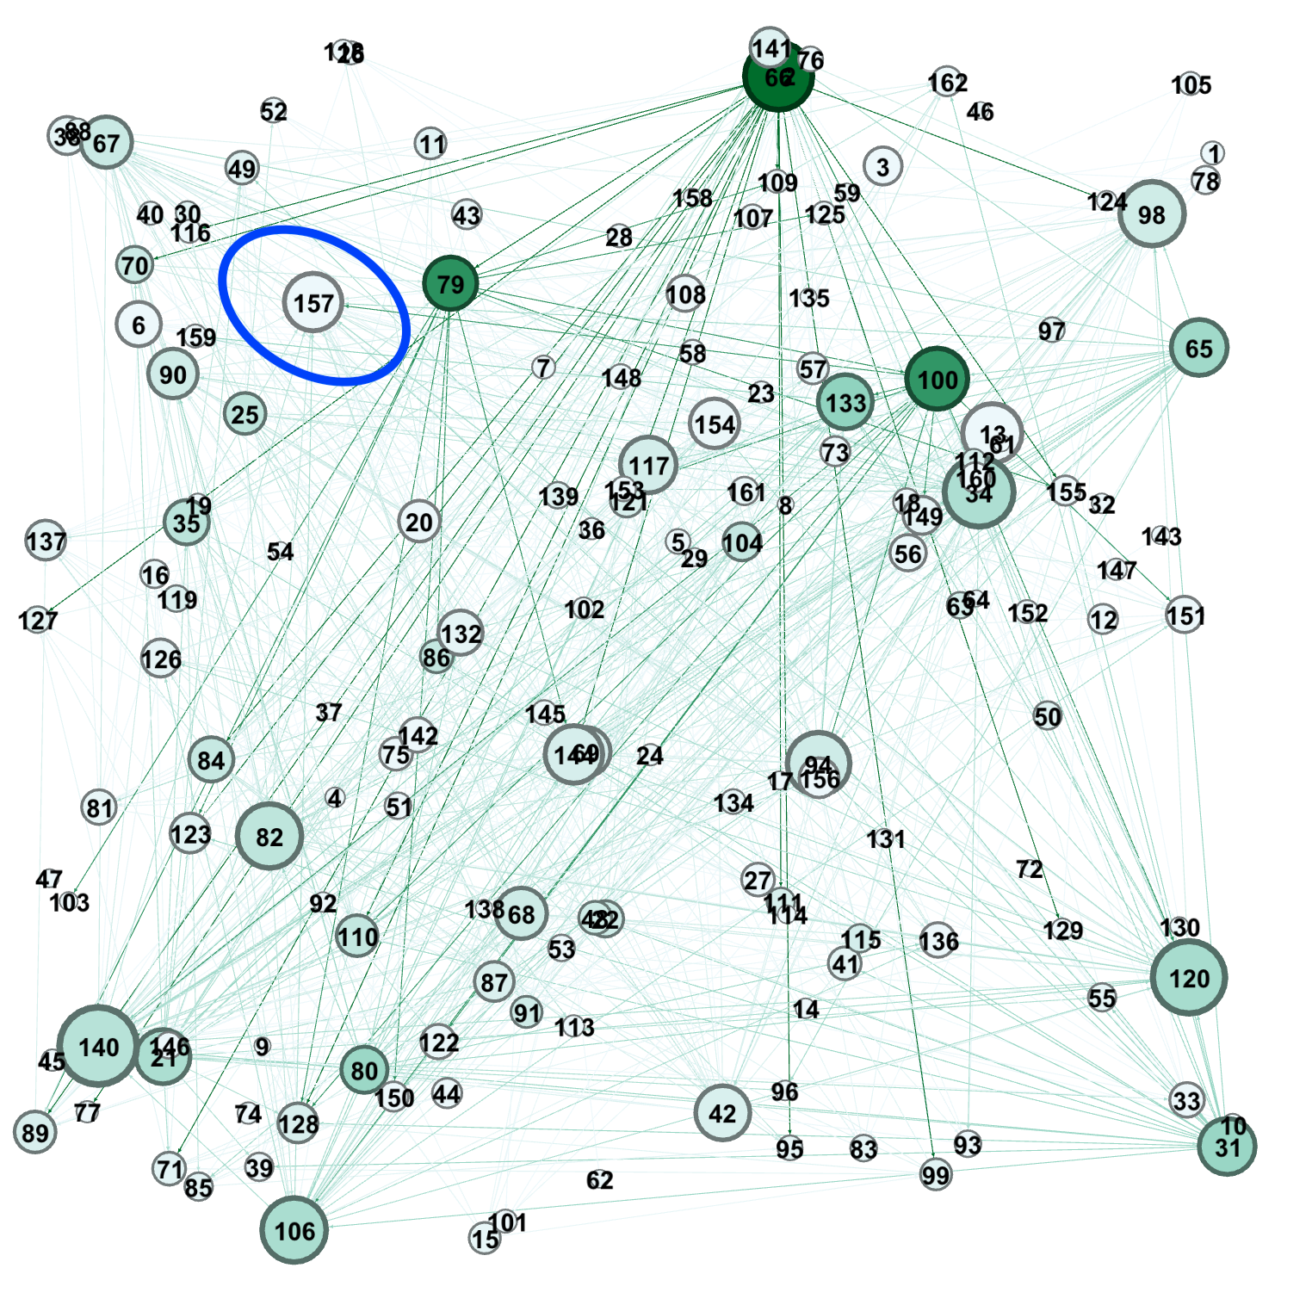

1. Node 142’s pageRank increased the most:

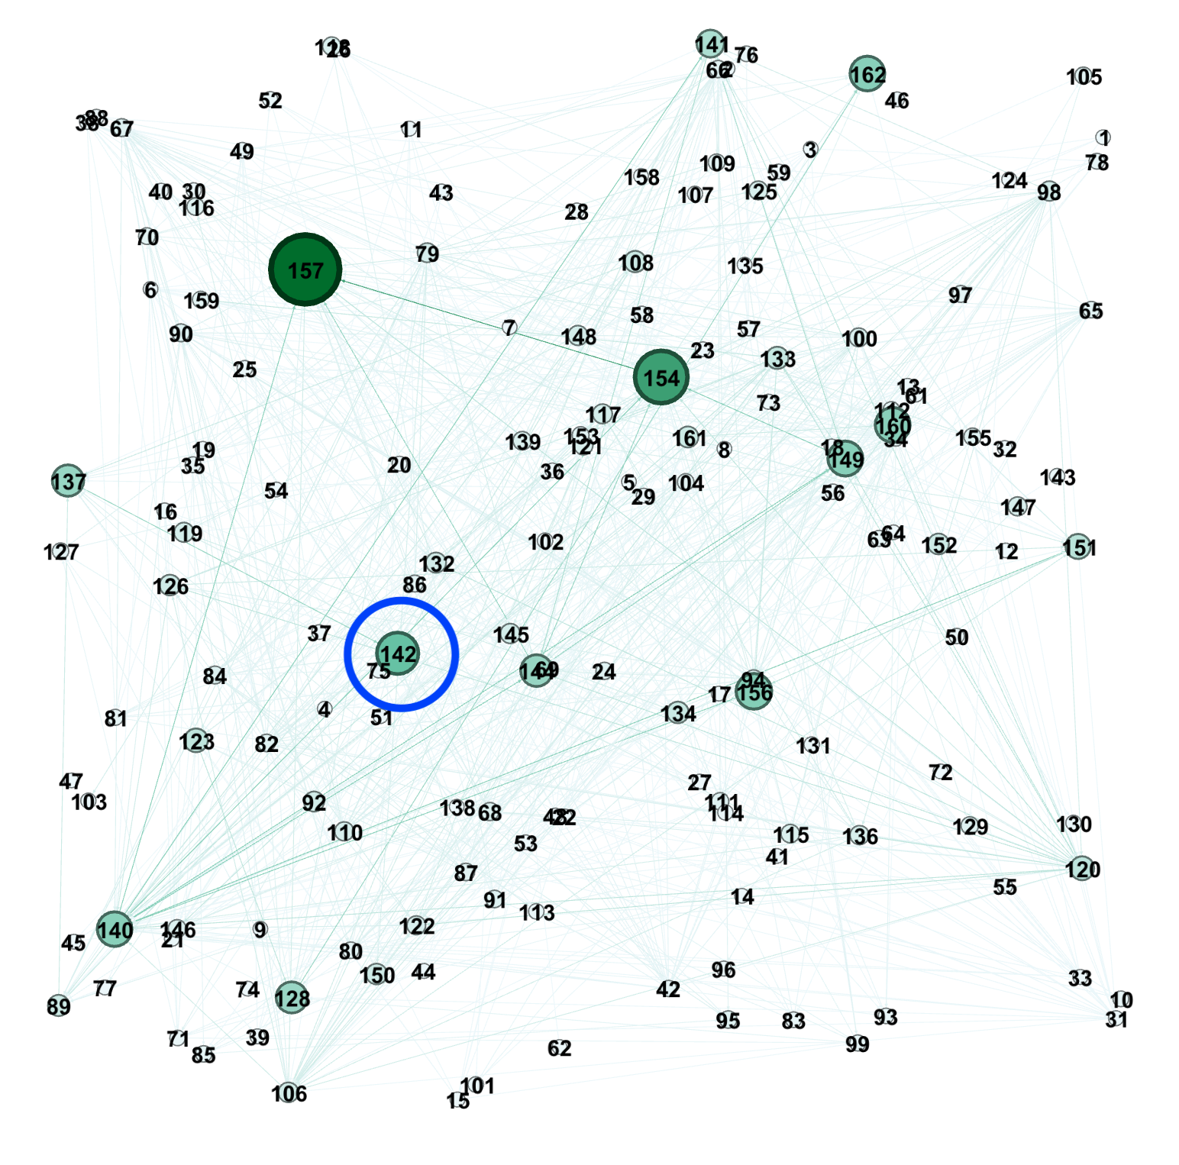

1. Node 79 had a change in its betweenness score since it was comparatively connected parts of the graph more than prior to removing node 60 from the network.
2. Node 127 had a change in its closeness score since it was comparatively closer to the other nodes in the network, now that node 60 has been removed. This change in closeness was the smallest change I found out of any of the metrics.